# SOP - high disk usage alert (moving shard to another node)

Check disk usage of all nodes: <https://console.sherlock.io/d/QVNizhaMk/production-monitoring-for-customers?orgId=1&var-namespace=pronto&var-escluster=esadsquality-slc&var-name=All&viewPanel=32&from=now-7d&to=now>

### Goal: exchange large-size shards on nodes with high disk usage with small-size shards on nodes with low disk usage.

### How: we have an end-to-end API in adsmondatasvc that serves this purpose

https://adsmondatasvc.vip.ebay.com/v1/es/balance-nodes

Query parameters it supports:

1. threshold: an integer between 0 and 100. Nodes whose disk usage percentage is above the threshold would be the target of size reduction.
2. node: the full name of the one node whose disk usage needs to be reduced, e.g. esadsquality-dataslc-slc-14-perfi
3. execute: a boolean value indicating whether to execute the actual shard exchange. Default to false. When execute=false, the API would return a list of request it would execute and lists of candidate large/small-size shards.

Example

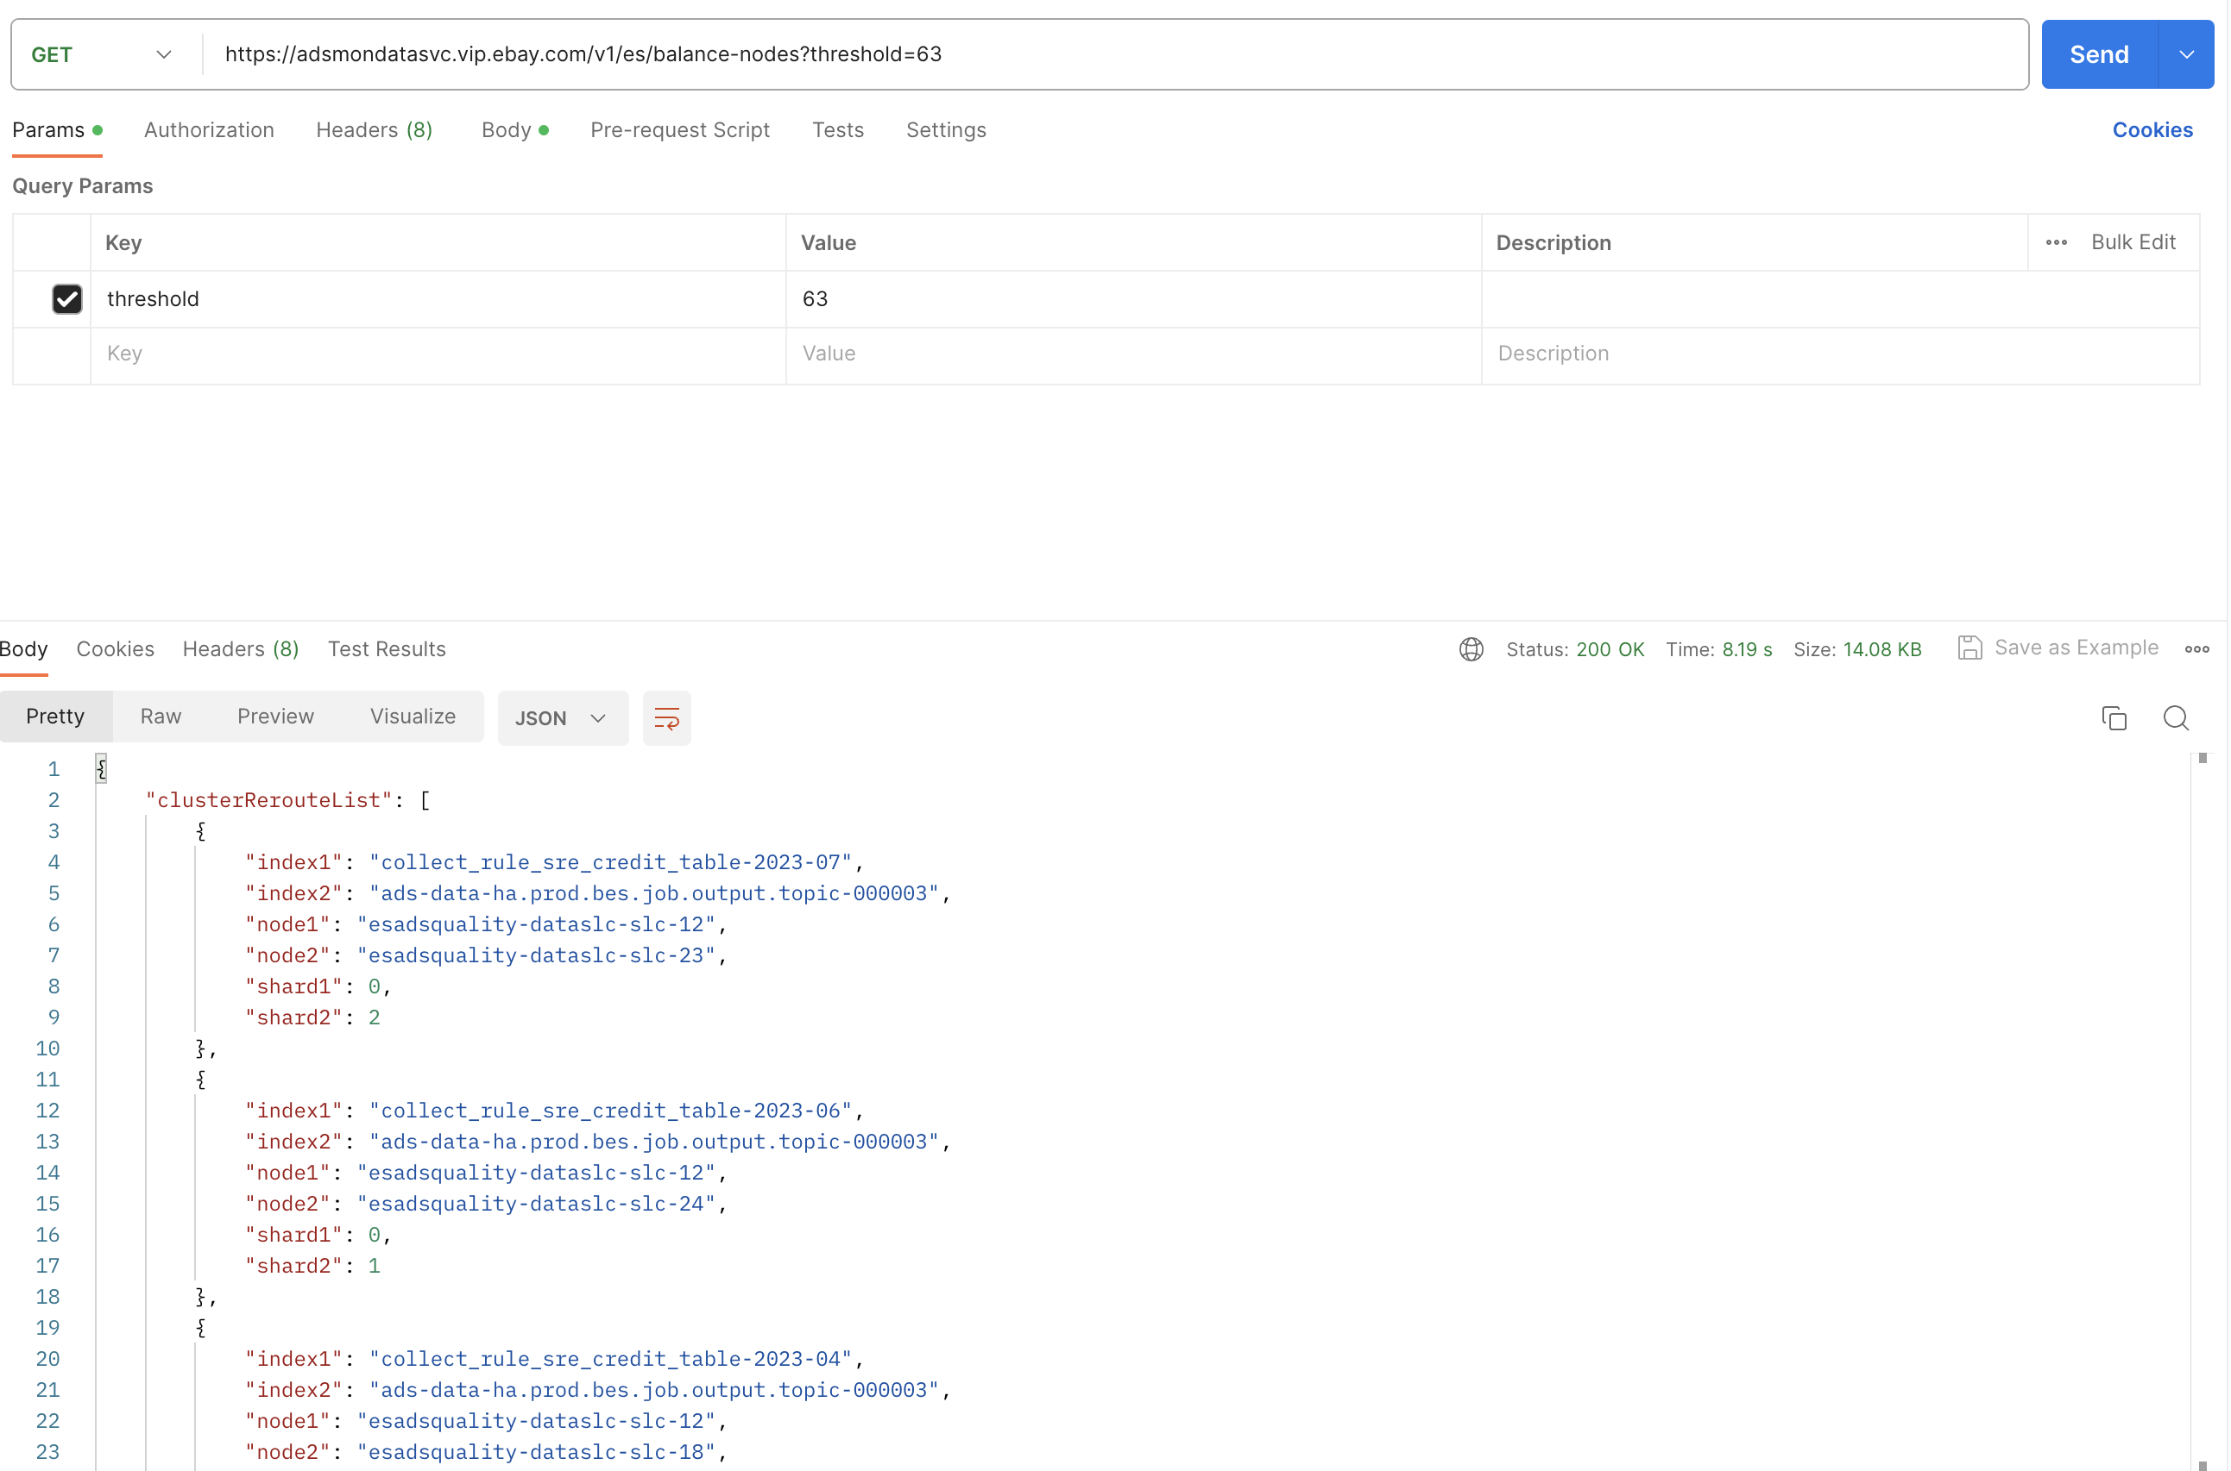

### Action:

1. Preview the request list by first querying the API **WITHOUT** execute=true
2. If the requests are safe to execute, either
   1. execute all requests by hitting the API endpoint **WITH** execute=true
   2. execute a single request using another API. Put the request in the payload

https://adsmondatasvc.vip.ebay.com/v1/es/cluster-reroute

Example

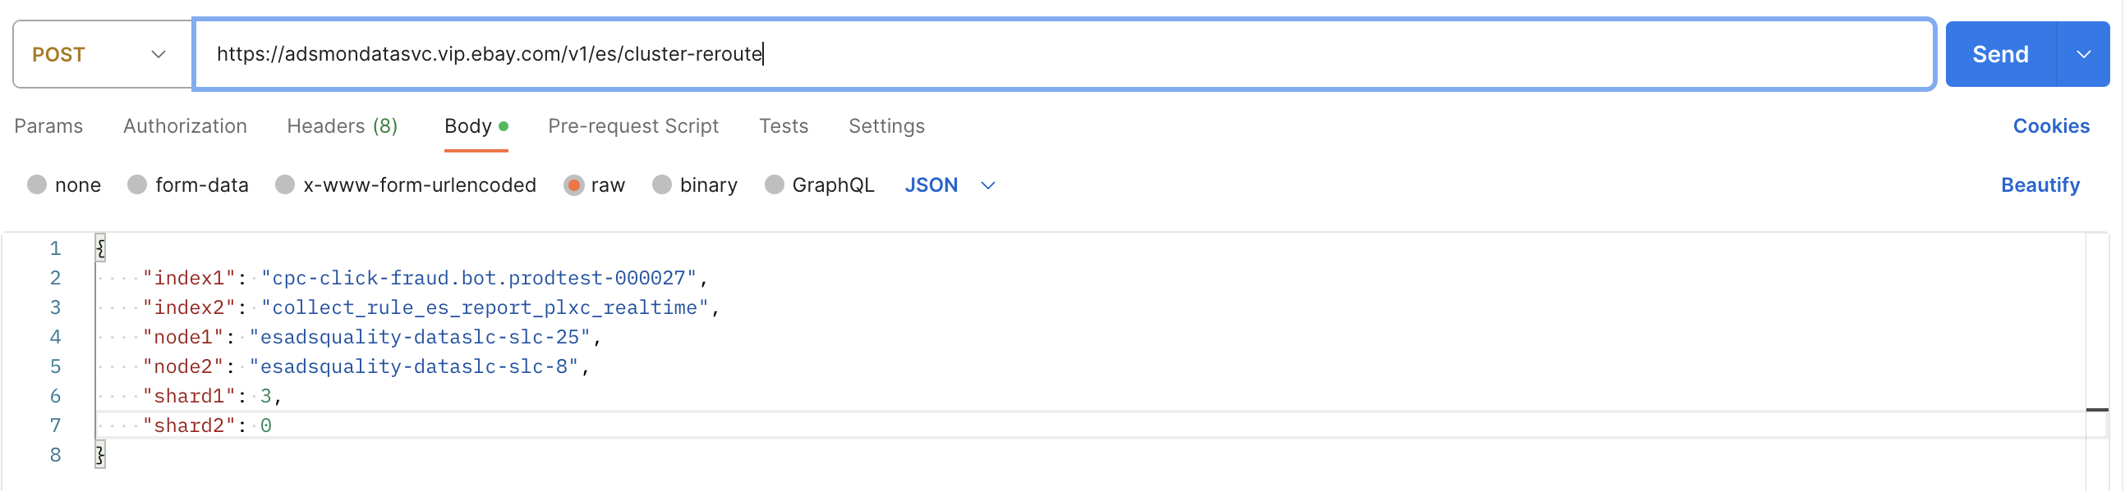

### Verify:

Verify if shard is now less than 75%. <https://console.sherlock.io/d/QVNizhaMk/production-monitoring-for-customers?orgId=1&var-namespace=pronto&var-escluster=esadsquality-slc&var-name=All&viewPanel=32&from=now-7d&to=now>

### Additional Action:

If there's generally not enough space in the ES cluster, submit a request for more space referring to this SOP: SOP to Handle High Disk Usage Alert